SHOPPING HUB APP

Aqib Iqbal (Group Leader) FA17-BCS-006

Abdullah Qureshi FA17-BCS-118

M Salman FA17-BCS-076

Hasnain Zia Fa17-BCS-132

**Project Proposal:**

Create an android application than can communicate with NodeMCU microcontroller over the internet using Google’s Firebase real-time database. The application will control the motor and leds on the microcontroller along with fetching the readings from the temperature sensors. The application will also for time based changes to the microcontroller.

**Note:** This project is part of our Final Year Project so we wish to complete this module in Mobile Application Development course as a semester project.

* Registration Module:

Time required: 7 days

Scope: It will include signup/login and authentication

* Displaying products:

Time required: 7 days

Scope: Displaying searched products on the result screen.

* Add to cart and checkout:

Time required: 7 days

Scope: User will be able to add products to cart and checkout for different paying methods.

**Module Distribution:**

* **Aqib Iqbal**

**Registration Screen**

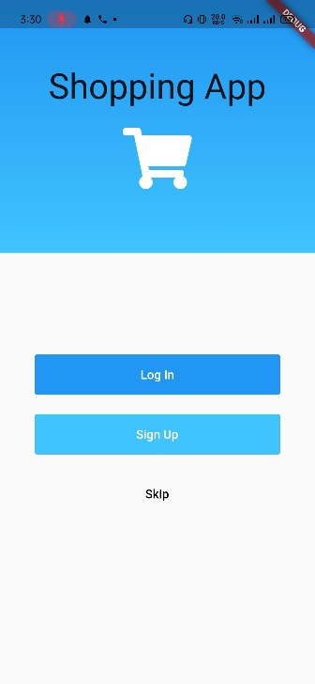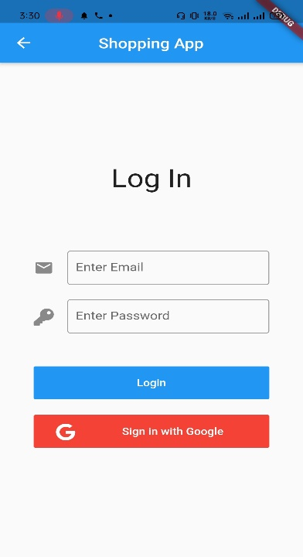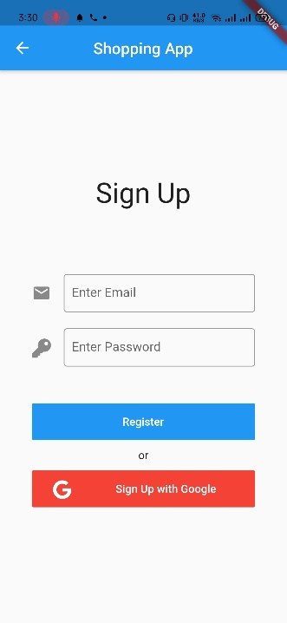

Getting registration and saving info in database. It will include signup/login and authenticationThe login activity will provide set of credentials used to authenticate a user.it consistof Email address and [password](https://techterms.com/definition/password).it is a security measure designed to prevent unauthorized access to data. If the user name and password does not match a user account, the user cannot access the app.

Reviewed By:

* Hasnain Zia  
  Comments:  
   Nil.

Abdullah Qureshi  
Comments:  
 Nil

* Salman Khan

Comments:

Nil

* **Abdullah Qureshi**

**Categories and Cart**

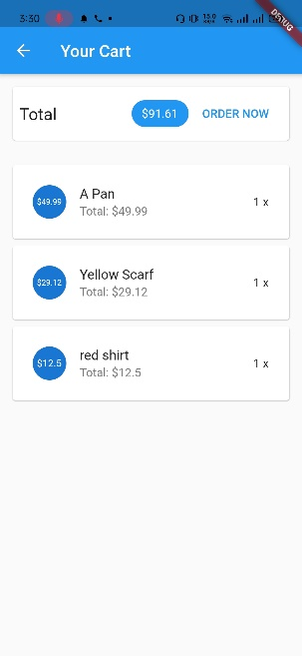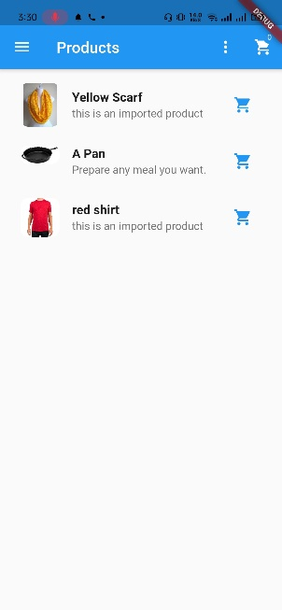

User of the app have the ability to view multiple products and these products to Cart. User will be able to search and apply filter on products.

**Reviewed by:** Hasnain Zia, Aqib Iqbal, Salman Khan

* **Salman Khan**

**My Order Screen:**

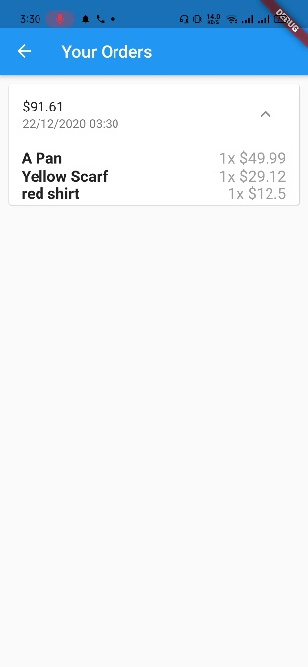

This screen will display all the products which have been ordered by the user. This will show some details about the order(product price, order date etc)

Reviewed By:

* Hasnain Zia  
  Comments:  
   Add some products.
* Abdullah Qureshi  
  Comments:  
   Nil
* Aqib Iqbal

Comments:

Nil

* **Hasnain Zia**

**Product Details:**

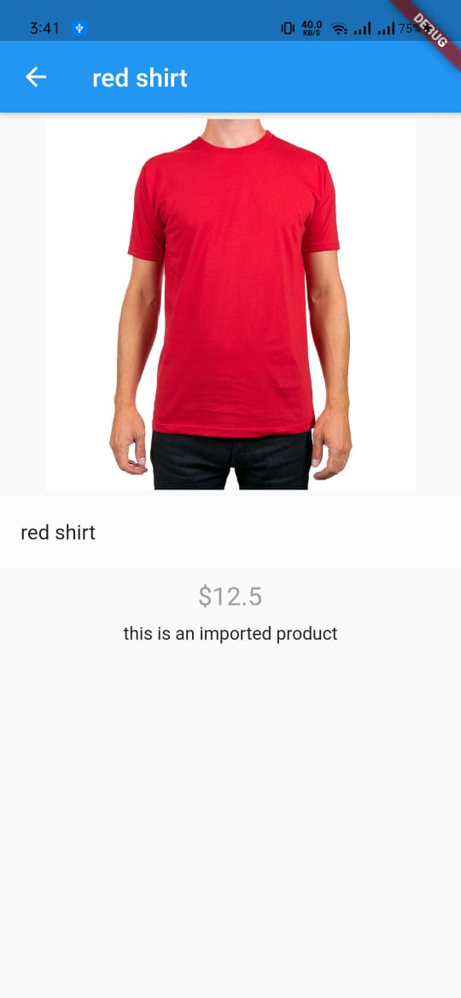

This screen will show the complete details of the product. This screen will have multiple pictures of the product, its Price, its Description, add to favourite icon.

Reviewed By:

* Aqib Iqbal  
  Comments:  
   Show Price in Pakistani Currency.
* Abdullah Qureshi  
  Comments:  
   Nil
* Salman Khan

Comments:

Nil